Assignment #4
Fundamental Concepts of Spatial Data Models in Geographic Information Systems (GIS)
Introduction
Geographic Information Systems (GIS) are designed to collect, store, analyze, manage, and visualize spatial or geographic data. A spatial data model is a framework that defines how real-world geographic features are represented digitally in GIS. These models help convert complex real-world phenomena into structured data that can be processed by computers. The two fundamental spatial data models are Object-based (Discrete) models and Field-based (Continuous) models. In addition, GIS uses different data transformation processes and data models (vector and raster) to represent and analyze spatial information effectively.

1. Object-based (Discrete) Model
Definition
The object-based or discrete model represents the world as a collection of distinct, identifiable objects. Each object has clear boundaries, a specific location, and defined attributes.

Main Characteristics
Represents individual features such as points, lines, and polygons
Each object is separate and uniquely identifiable
Objects have attributes stored in tables (e.g., name, type, population)
Boundaries are clearly defined
Advantages
Easy to understand and closely matches how humans perceive real-world features
Efficient for storing and managing discrete features
Supports detailed attribute information
Suitable for network analysis and cadastral mapping
Suitable Examples
Buildings
Roads and highways
Rivers
Administrative boundaries (countries, districts, plots)
2. Field-based (Continuous) Model
Definition
The field-based or continuous model represents geographic phenomena that vary continuously over space. Every location in the study area has a value.
Main Characteristics
Represents spatial variation as a surface or field
No clear boundaries between values
Values change gradually across space
Often represented using raster data

Advantages
Ideal for natural phenomena
Useful for spatial analysis such as surface modeling
Supports mathematical and statistical operations

Suitable Examples
Temperature distribution
Rainfall intensity
Elevation (Digital Elevation Model – DEM)
Air pollution levels

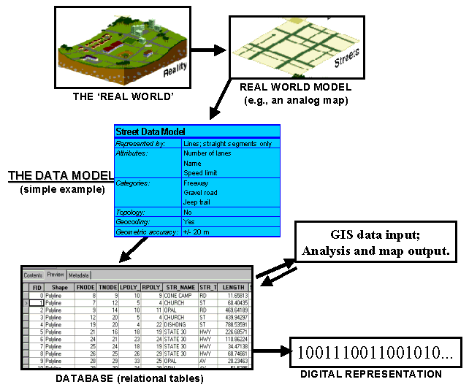

3. Data Transformation Processes in GIS
Data transformation processes help convert raw spatial data into meaningful representations suitable for analysis.

a) Interpolation / Gridding
Interpolation estimates unknown values at unsampled locations using known sample points. Gridding creates a continuous surface from point data.

Role in GIS:

Converts point data into continuous surfaces
Helps visualize spatial trends
Example: Creating a temperature map from weather station data.

b) Approximation
Approximation simplifies complex spatial data while maintaining essential patterns. It reduces data complexity and noise.

Role in GIS:
Makes data easier to process and analyze
Improves performance of GIS operations
Example: Generalizing a detailed road network for small-scale maps.

c) Object Recognition
Object recognition identifies and extracts meaningful objects from raw spatial data, such as satellite images.

Role in GIS:

Converts raster data into vector objects
Useful in image classification and feature extraction
Example: Identifying buildings or roads from satellite imagery.

4. Data Models in GIS
GIS primarily uses two data models for spatial representation: Vector and Raster.

a) Vector Data Model
Description
Represents spatial features using geometric shapes:
Points (e.g., wells, trees)
Lines (e.g., roads, rivers)
Polygons (e.g., land parcels, lakes)

Benefits
High positional accuracy
Efficient storage for discrete data
Excellent for cartographic representation
Supports attribute-rich databases

Appropriate Use Cases
Urban planning

Transportation networks

Land ownership and cadastral systems

b) Raster Data Model
Description
Represents spatial data as a grid of cells (pixels), where each cell has a value.

Benefits
Ideal for continuous data

Simple data structure

Efficient for spatial analysis and modeling

Widely used with remote sensing data

Appropriate Use Cases
Elevation and terrain analysis

Climate and environmental modeling

Satellite and aerial imagery

5. Comparison of Vector and Raster Models
Feature Vector Model Raster Model
Data Type Discrete Continuous
Accuracy High Depends on cell size
Storage Efficient for sparse data Large file sizes
Analysis
Network and attribute analysis Surface and overlay analysis
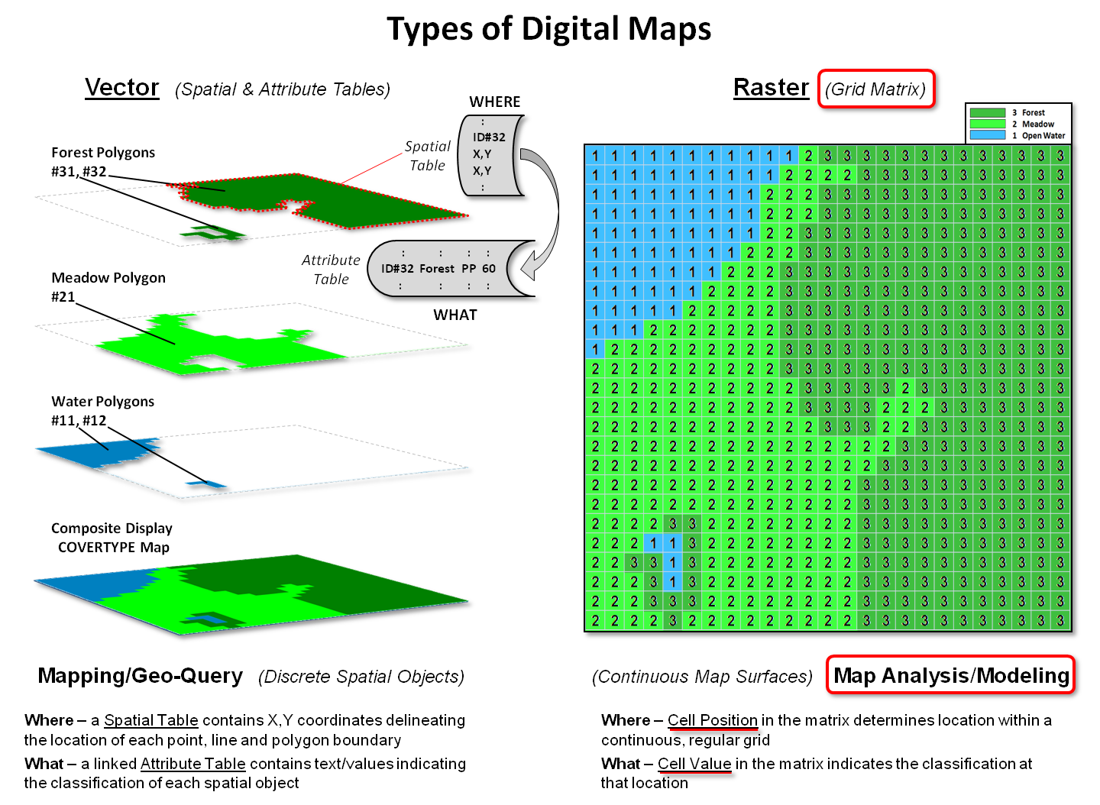

Conclusion
Spatial data models are the foundation of GIS. The object-based (discrete) model is suitable for clearly defined geographic features, while the field-based (continuous) model is ideal for representing natural phenomena that vary smoothly over space. Data transformation processes such as interpolation, approximation, and object recognition play a critical role in converting raw data into meaningful spatial representations. Finally, vector and raster data models provide complementary ways to store and analyze spatial data, each with its own strengths and appropriate applications. Understanding these concepts is essential for effective GIS analysis and decision-making.

